­



**Submitted To:**

**Sonia Nasrin**

Lecturer

Department of CSE

Daffodil International University

**Submitted By:**

**Mahadi Hasan Munna**

ID: 203-15-3881

Section: PC – A

Department of CSE

Lab Report

**Course Name: Microprocessor, Embedded Systems & IoT lab**

**Course Code: CSE 232**

**Lab 1**

**1. Printing my name with print function.**

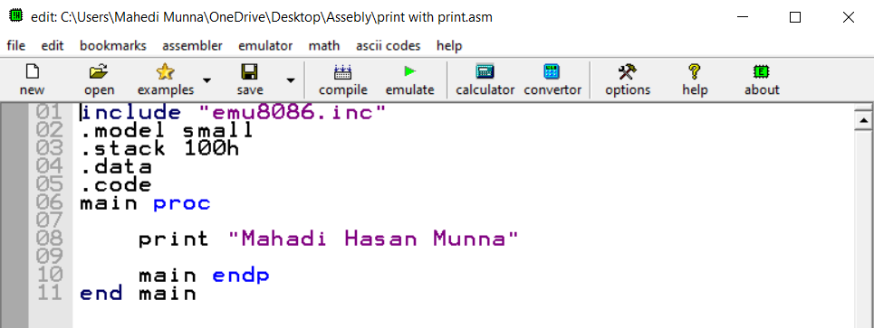

**Output:**

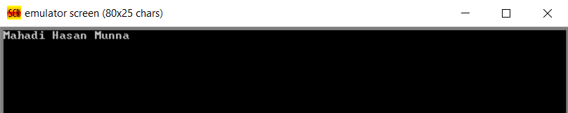

**2. Printing my name with assembly**

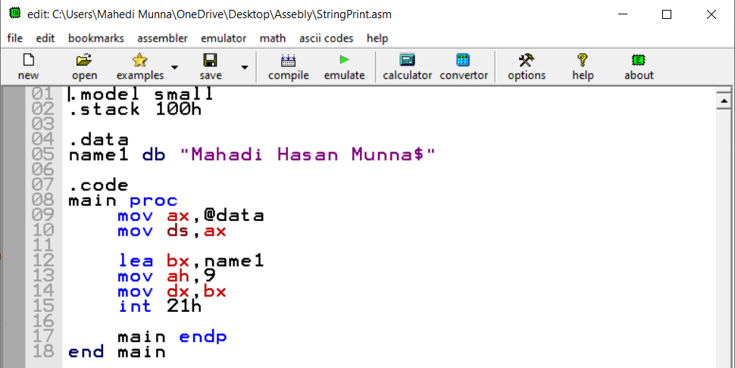

**Output:** 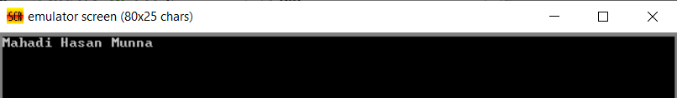

**Lab 2**

**1. Print a number** 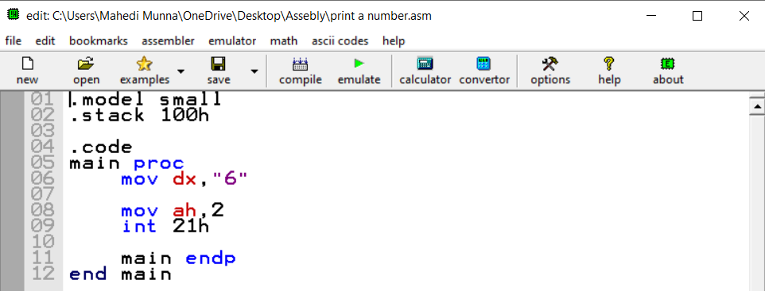

**Output:**



**2. Take a user input and print it.**

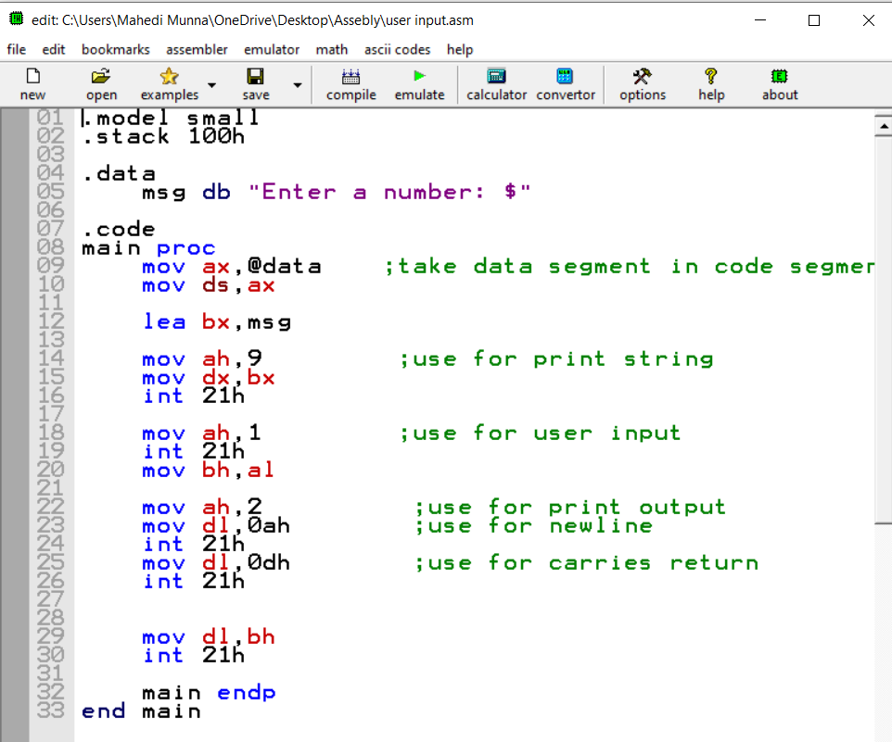

**Output:**

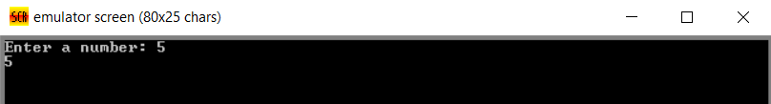

**3. Add 3 Numbers**

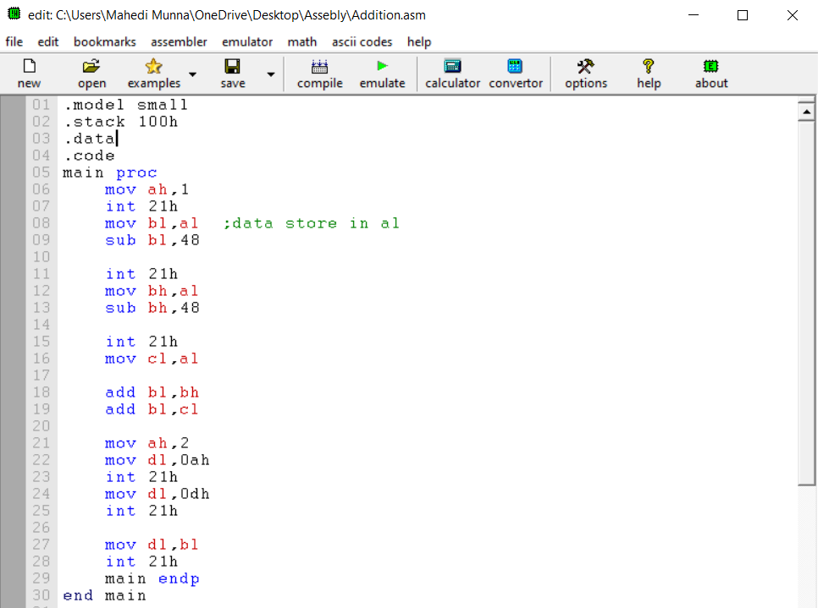

**Output:**

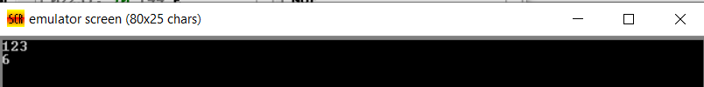

**4. Subtraction 2 numbers** 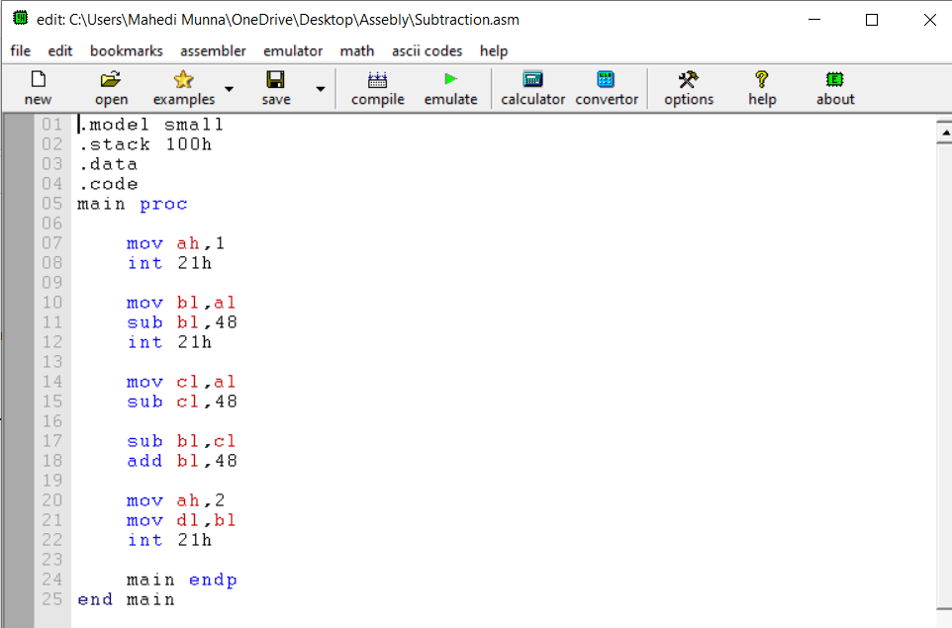

**Output:** 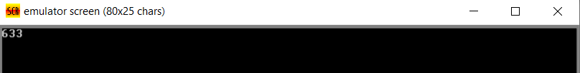

**5. Negation** 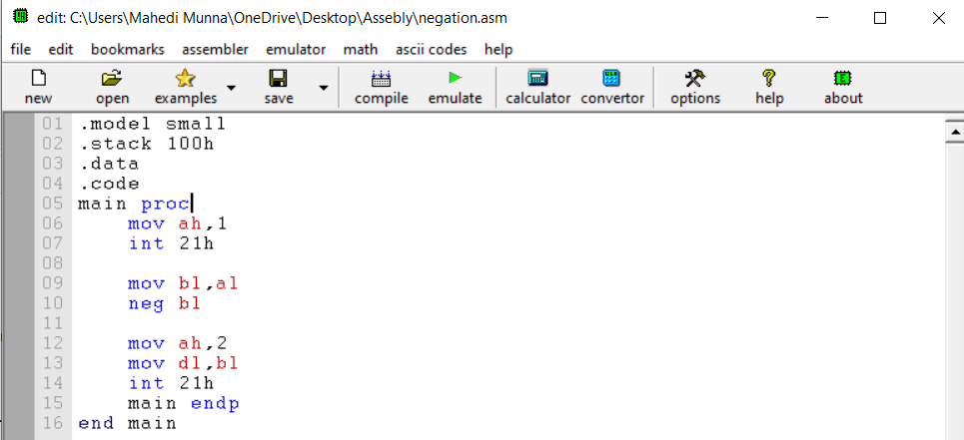

**Output:**

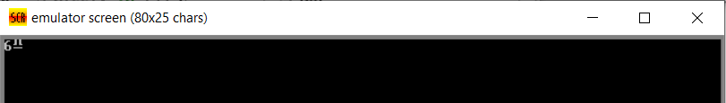

**Lab 3**

**1.Jump**

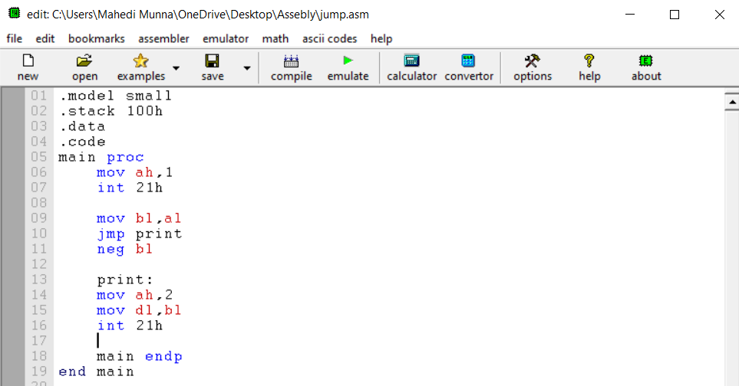

**Output:**

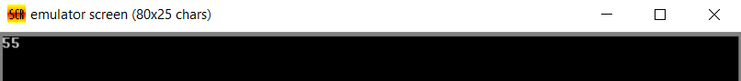

**2. Conditional Jump [If zero then print * else #]**

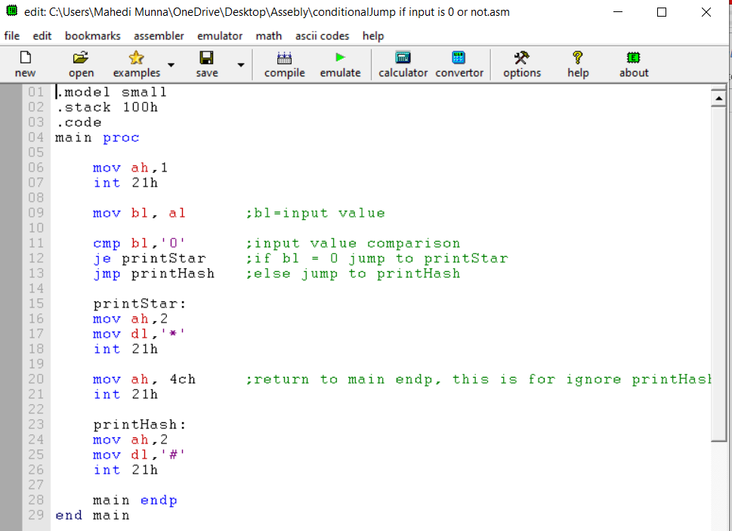

**Output:**

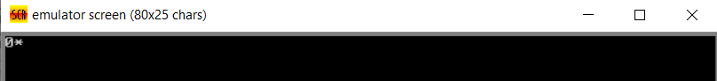

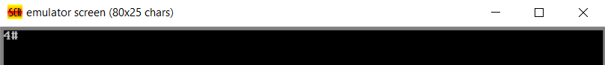

**3. Conditional jump [Capital/small, vowel/not vowel, alphabet/not]**

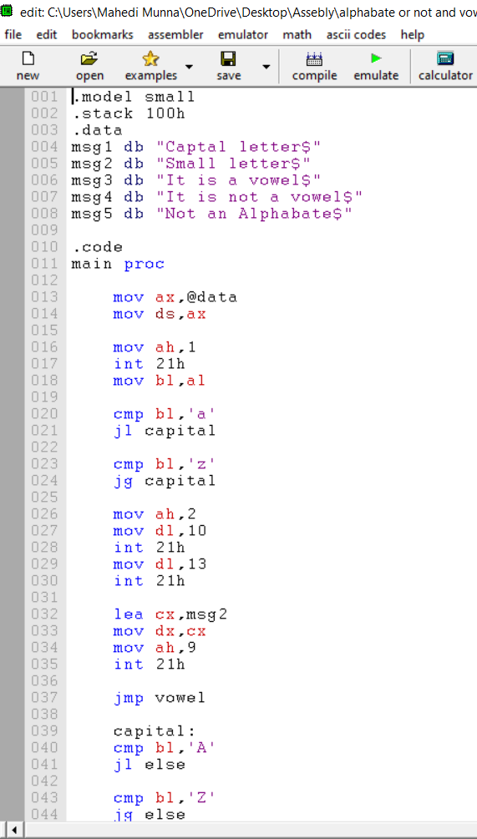

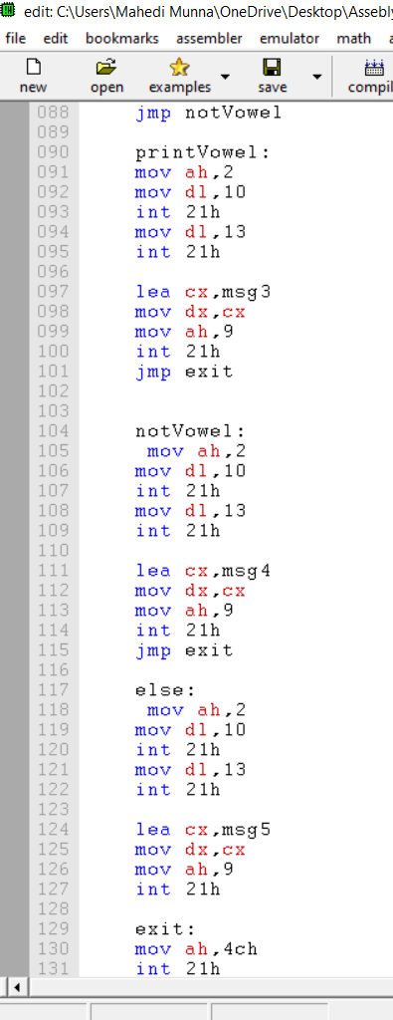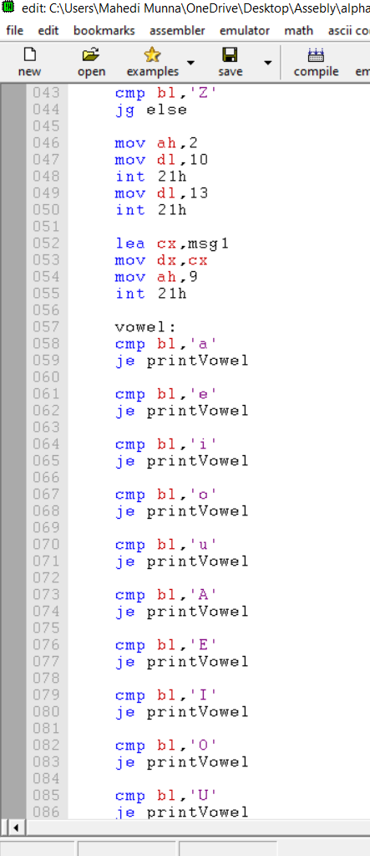

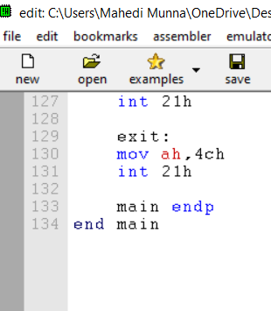

**Output:**

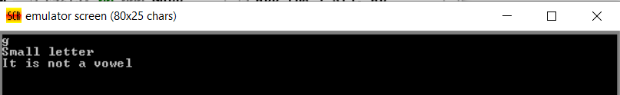

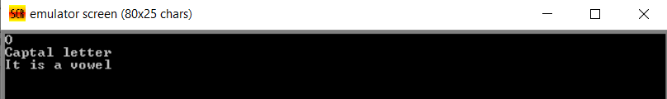

4. Exchange Number

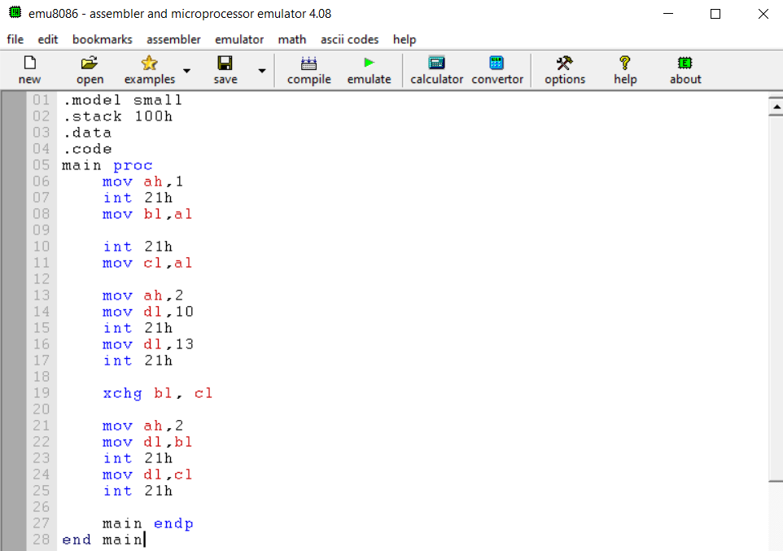

Output:

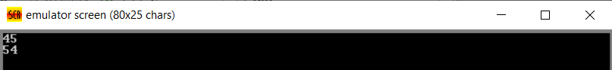

Lab 4

1.Compare and print biggest

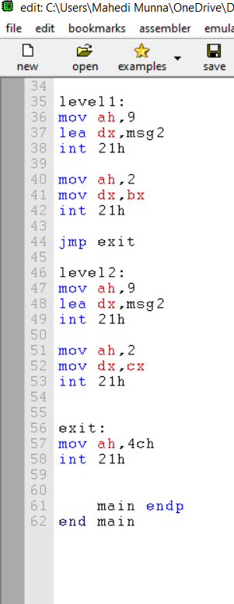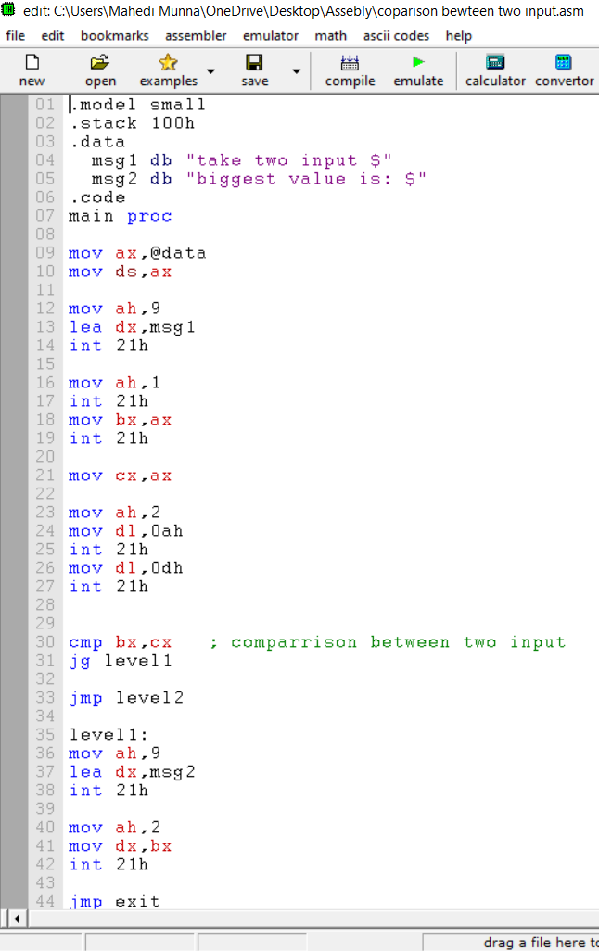

Output:

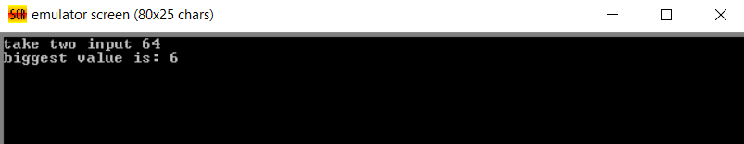

2. Even or Odd between 1 – 4

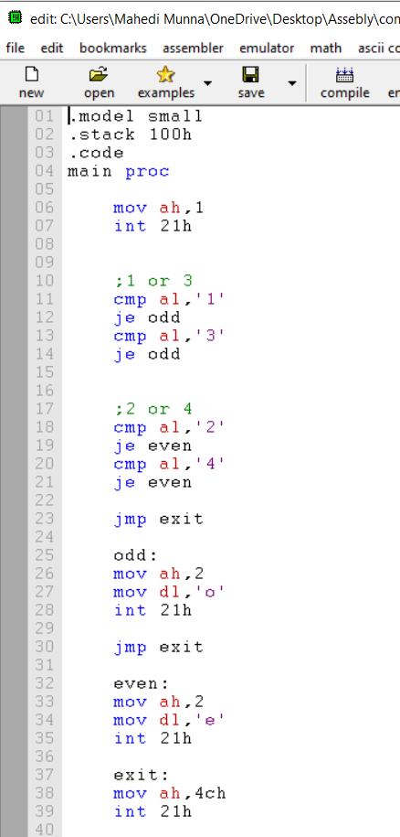

Output:

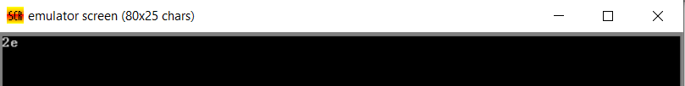

Lab 5

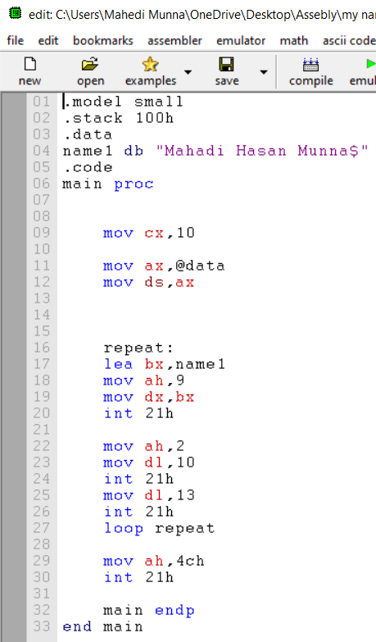1.Print name 10 times with loop

Output:

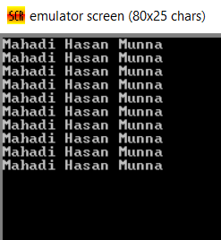

2. Print A to Z

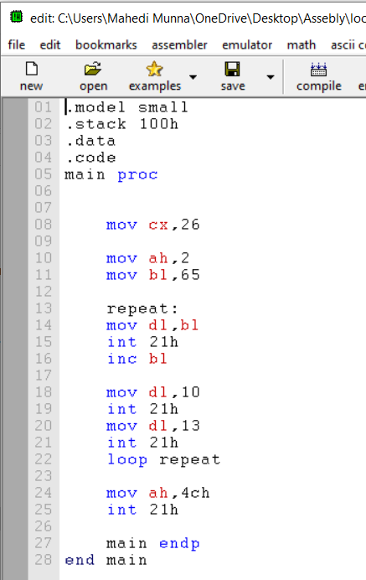 Output:

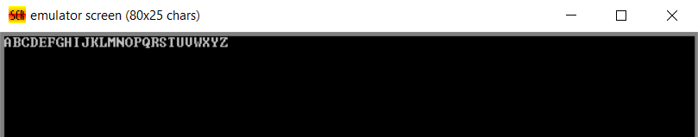

3. Print star with decrement

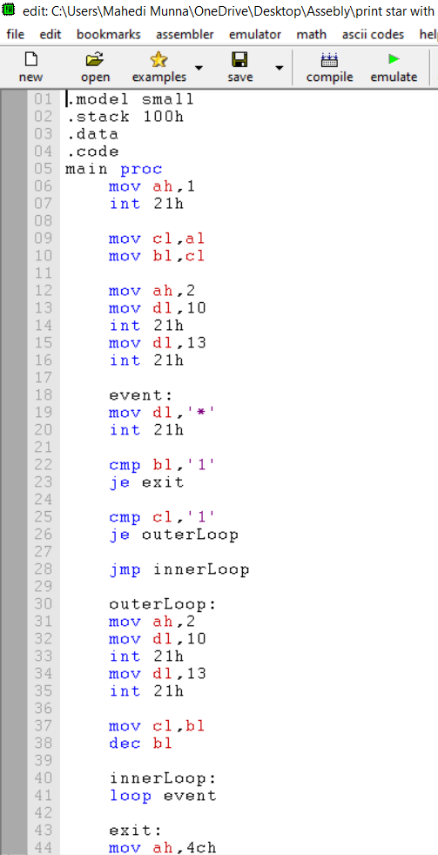

Output:

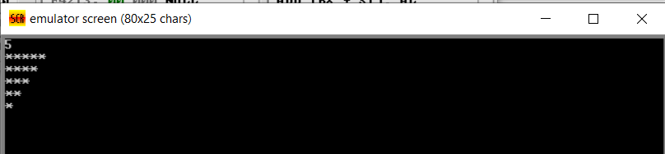

Lab 6

1.Reverse a string

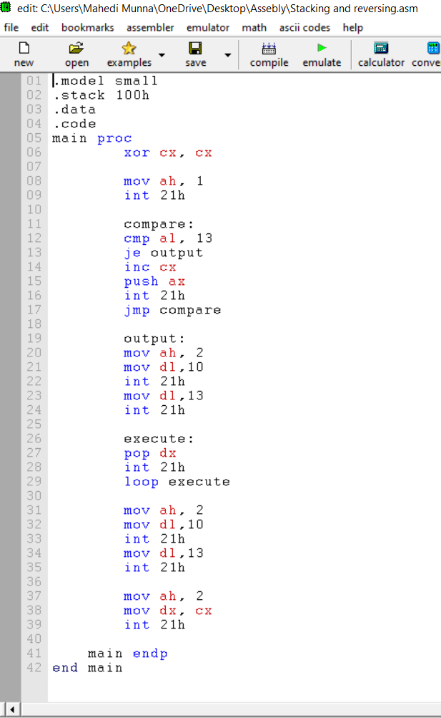

Output:

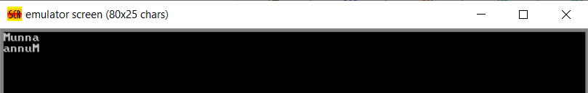

2. Count number of 1

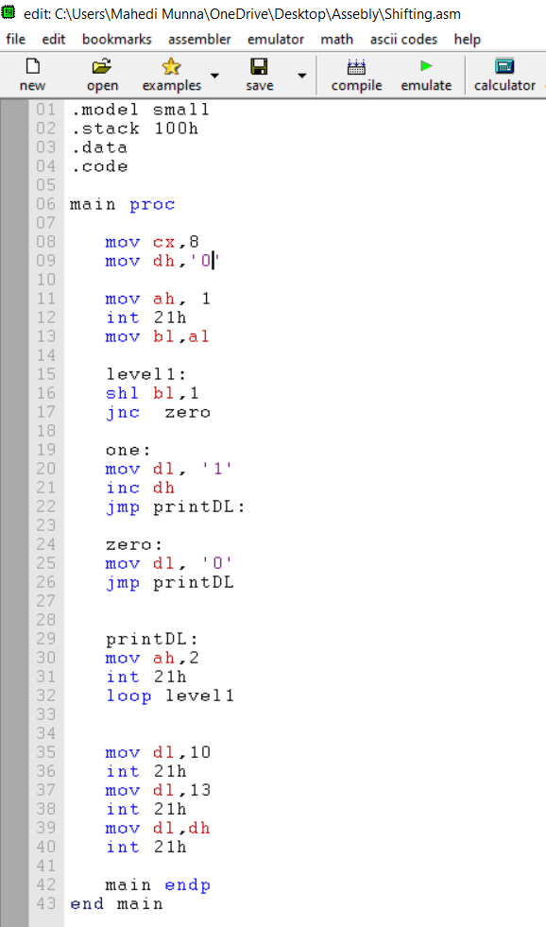

Output:

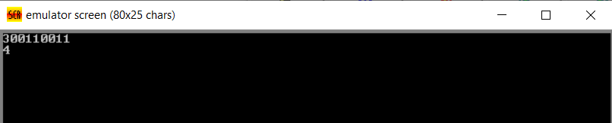

Lab 7

1. Temperature Sensor:

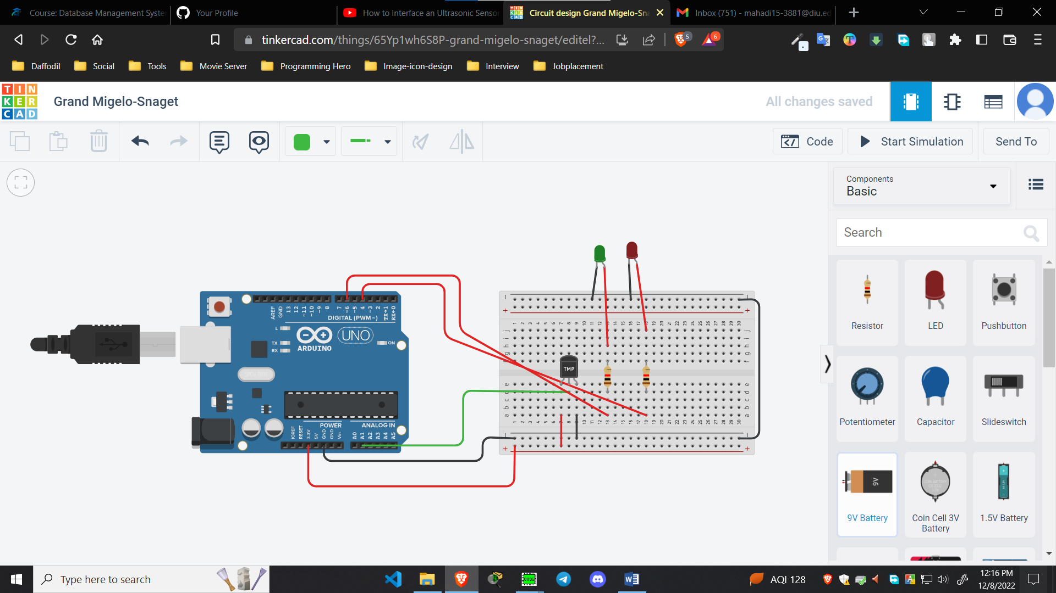

**Code:**

void setup()

{

pinMode(A1, INPUT);

pinMode(6, OUTPUT);

pinMode(4, OUTPUT);

Serial.begin(9600);

}

void loop()

{

float value = analogRead(A1);

float voltage = value * (5/1024.0);

float temp = (voltage - 0.5) * 100;

Serial.print("Temp value: ");

Serial.println(temp);

if(temp>10) {

if(temp<50) {

digitalWrite(6, HIGH);

digitalWrite(4, LOW);

}

else {

digitalWrite(4,HIGH);

digitalWrite(6,LOW);

}

}

else{

digitalWrite(4,HIGH);

digitalWrite(6,LOW);

}

delay(100);

}

